Mars

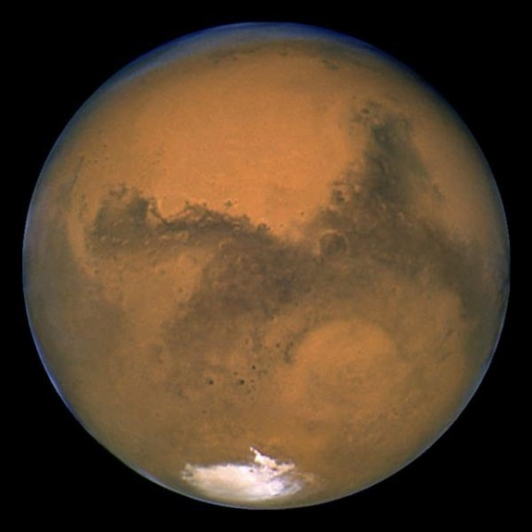
Date of discovery: Prehistoric
Distance from the Sun: 227,936,640 km.
Period of Revolution around the Sun: 686.98Earth days
Period of Rotation: 24.6 Earth hours = 1.026 Earth day
Volume: 1.6318x10¹¹ km.³ (0.151 Earths)
Mass: 6.42x10²³ kg. (0.107 Earths)
Density: 3.934g/cm.³
Diameter: 6,794 km.
Mean Surface Temperature: -227K (13.8 ºC or 56.93 ºF)
Satellite: 2

- The fourth planet from the Sun and the seventh largest.
- Greek: Ares, the god of war.
- Sometimes referred to as the Red Planet. The surface of Mars is much colder than Earth.
- The average surface temperature on Mars is about 218K (-55ºC or -67ºF).
- Has the most highly varied and interesting terrain of any of the terrestrial planets (Olympus Mons, Tharsis, Valles Marines, Hellas Planitia).
- Much of the Martian surface is very old and cratered.
- Its southern hemisphere consists of plains which are much younger, lower in elevation and have a much more complex history.
- Mars’ relatively low density compared to the other terrestrial planets indicates that its core probably contains a relatively large fraction of sulfur in addition to iron.
- Mars appears to lack active plate tectonics at present; there is no evidence of recent horizontal motion of the surface such as the folded mountains so common on Earth.
- There is no evidence of current volcanic eruption.
- There is very clear evidence of erosion in many places on Mars including large floods and small river systems.
- Mars has a very thin atmosphere composed mostly of the tiny amount of remaining carbon dioxide (95.3%), plus nitrogen (2.7%), argon (1.6%) and traces of oxygen (0.15%) and water (1.03%).
- The average pressure on the surface of Mars is only about 7 milllibars.

