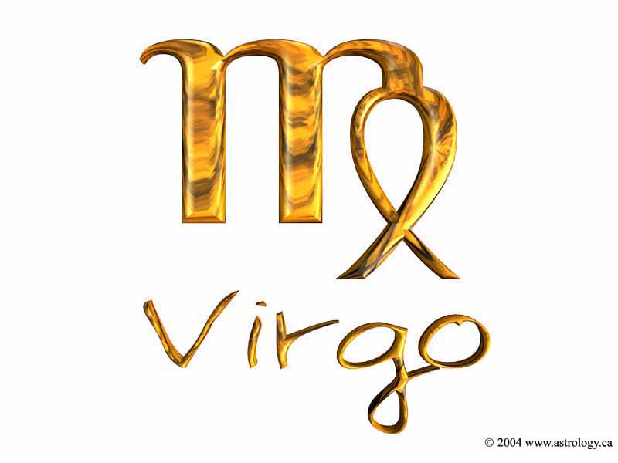

Submitted By: Jomar M. Urbano
2SED-SC
Submitted To: Mrs. Estrella Del Rosario
Professor
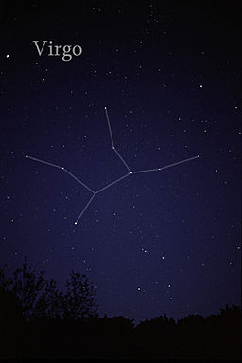
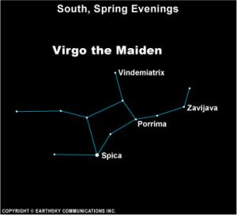

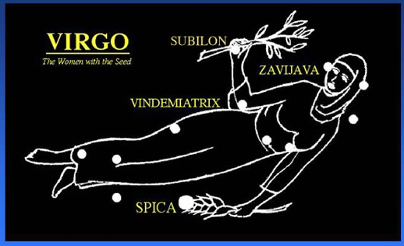

Virgo

Virgo is the second largest constellation (after Hydra). As a member of the Zodiac, Virgo has a number of ancient myths and tales. The Sun passes through Virgo in mid-September (August 23-September 23), and is therefore the constellation that announces the harvest.

Virgo is often represented as a "Maiden" (as its name indicates). In antiquity, she may have been Isis, the Egyptian protectress of the living and the dead and the principal mother goddess. She was also Ishtar of the Sumerian-Chaldean civilisations, or "Inanna", meaning Queen of Heaven. Inanna is described by Kramer (The Sumerians) as an ambitious, aggressive, and demanding goddess of love.

In Roman times the goddess Ceres was depicted: the goddess of the growth of food plants and harvests, and particularly corn. Her festival was in the second week of April, the same time that the constellation appears in the Spring skies.

The Romans had simply adopted an earlier Greek goddess, Demeter. This goddess of agriculture was of the highest birth: born to Cronus and Rhea, she was the sister of Zeus. As evidence of her antiquity in Greek lore, her name has been found on a tablet from Pylos dating to the thirteenth century B.C.

Demeter was said by Homer to have "lain with Iasion in a thrice-plowed field", the result of which was the birth of Plutus, whose name translates as "riches from the soil" (perhaps "cornucopia" would be an appropriate description). The goddess was depicted then, as now, as carrying a sheaf of wheat. But her influence carried not only to cereal crops, but to all kinds of food crops. Not surprisingly, perhaps, she was also the goddess of health, and of births and marriages.

A ceremony held in her honour in ancient Greece was called Proarktouria, which possibly indicates that the festivities were held just before the rising of Arcturus. However the name may instead make reference to the constellation Virgo, which in fact rises just before the star Arcturus.

Virgo is unique in that it is the only constellation containing all the Bayer stars with no additional superscript letters or numbers: just the Greek alphabet from alpha to omega.

Alpha Virginis is known as Spica: the "ear of wheat" that the goddess is carrying. Spica is a blue-white eclipsing binary with a period of just over four days. The star is about twice the size of the Sun, but with a luminosity of about 2000 times the Sun.

Gamma Virginis carries the name of the Roman goddess of prophecy: Porrima. Porrima is a notable binary of twin stars (see below). It's 32.9 light years distant and has the diameter of 1.5 Suns.

Location
The bright Spica makes it easy to locate Virgo, as it can be found by following the curve of the Big Dipper to Arcturus in Boötes and continuing from there in the same curve ("follow the arc to Arcturus and speed on to Spica"). Due to the effects of precession, the First Point of Libra, (also known as the autumn equinox point) lies within the boundaries of Virgo very close to β Virginis. This is one of the two points in the sky where the celestial equator crosses the ecliptic (the other being the First Point of Aries, now in the constellation of Pisces.) This point will pass into the neighbouring constellation of Leo around the year 2440.

Notable features

Stars
Besides Spica, other bright stars in Virgo include β Virginis (Zavijava), γ Vir (Porrima), δ Virginis (Auva) and ε Virginis (Vindemiatrix). Other fainter stars that were also given names are ζ Virginis (Heze), η Virginis (Zaniah), ι Virginis (Syrma) and μ Virginis (Rijl al Awwa). The star 70 Virginis has one of the first known extrasolar planetary systems with one confirmed planet 7.5 times the mass of Jupiter. The star Chi Virginis has one of the most massive planets ever detected, at a mass of 11.1 times that of Jupiter. The sun-like star 61 Virginis has three planets: one is a super-Earth and two are Neptune-mass planets. SS Virginis is a variable star with a noticeable red color. It varies in magnitude from a minimum of 9.6 to a maximum of 6.0 over a period of approximately one year.

Exoplanets
With 26 known exoplanets orbiting around 20 stars in this constellation, Virgo has more confirmed exoplanets than any other constellation. 8 planets in this constellation were discovered in 2009, which is the most planets discovered in a single constellation in a single year.

Deep-sky objects
Because of the presence of a galaxy cluster (consequently called the Virgo cluster) within its borders 5° to 10° west of ε Vir (Vindemiatrix), this constellation is especially rich in galaxies.
Some examples are Messier 49 (elliptical), Messier 58 (spiral), Messier 59 (elliptical), Messier 60 (elliptical), Messier 61 (spiral), Messier 84 (lenticular), Messier 86 (lenticular), Messier 87 (elliptical and a famous radio source), Messier 89 (elliptical) and Messier 90 (spiral). A noted galaxy that is not part of the cluster is the Sombrero Galaxy (M104), an unusual spiral galaxy. It is located about 10° due west of Spica.

