Venus
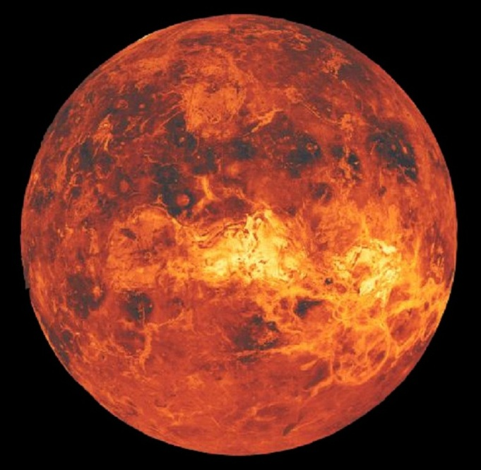
Date of discovery: Prehistoric
Distance from the Sun: 108,208,930 km.
Period of Revolution around the Sun: 224.68 Earth days
Period of Rotation: 243 Earth days
Volume: 9.38x10¹¹ km.³ (0.857 Earths)
Mass: 4.87x10²⁴ kg. (0.815 Earths)
Density: 5.204 g/cm.³
Diameter: 12, 104 km.
Mean Surface Temperature: 735K (461.85 ºC or 863.33 ºF)
Satellite: 0

- The second planet from the Sun and the sixth largest.
- Greek: Aphrodite; Babylonian: Ishtar, the goddess of love and beauty.
- The brightest of the planets known to the ancient.
- It was popularly thought to be two separate bodies: the morning star and the evening star.
- Venus’ rotation is somewhat unusual in that it is both very slow (243 Earth days per Venus day), and is retrograde.
- It is regarded as Earth’s Sister Planet.
- It is composed mostly of carbon dioxide.
- There are several layers of clouds many kilometers thick composed of sulfuric acid.
- Venus’ surface temperature is about 400 to 740 K with the mean surface temperature of 735K (461.85 ºC or 863.33 ºF).
- It has several broad depressions: Atalanta Planitia, Guineverre Planatia and Lavinia Planitia.
- It has several large volcanoes such as Sif Mons.
- Craters on Venus seem to come in bunches indicating that large meteoroids that do reach the surface usually break up in the atmosphere.
- Has no magnetic field because of its slow rotation.

