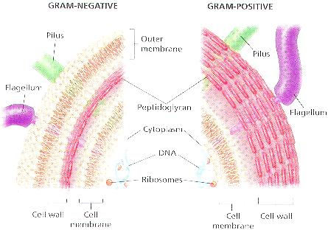

CELL BIOLOGY
ASSIGNMENT
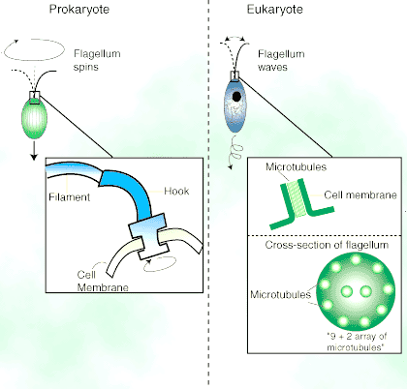

- Difference between Gram-positive and Gram-negative Bacterial Flagellum.
The bacterial flagellum is made up of the protein flagellin. Its shape is a 20 nanometer-thick hollow tube. It is helical and has a sharp bend just outside the outer membrane; this "hook" allows the axis of the helix to point directly away from the cell. A shaft runs between the hook and the basal body, passing through protein rings in the cell's membrane that act as bearings.
Gram-positive organisms have 2 of these basal body rings, one in the peptidoglycan layer and one in the plasma membrane.

Gram-negative organisms have 4 such rings: the L ring associates with the lipopolysaccharides, the P ring associates with peptidoglycan layer, the M ring is embedded in the plasma membrane, and the S ring is directly attached to the plasma membrane. The filament ends with a capping protein.

- Difference between Prokaryotic and Eukaryotic Flagellum.

- The Prokaryotic Flagellum
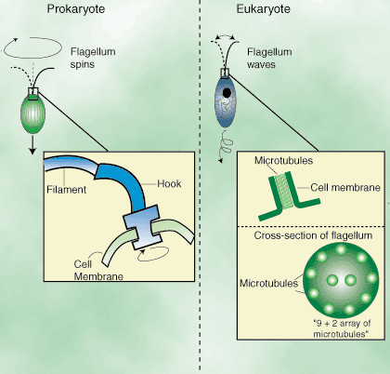
Bacteria invented the wheel! The bacterial flagellum is a helical structure that drives the cell through the media like a propeller. The structure is rigid and turned by a rotatory motor at the base where it connects to the bacteria's body. The rotary motor consists of several wheel-like discs one of which the M-ring (and/or possibly the S-ring) interacts with the C-ring and studs to rotate the whole structure. The rotary motor is very like a stepping motor! The flagella is composed of a protein called flagellin which is synthesized in the cell body and transported through the narrow lumen of the growing flagella itself to polymerise at the tip as it is about to exit the bacteria! This system has evolved into a syringe –like mechanism to inject toxins into the cells of vertebrates during infection (this is called "type 3 secretion"). There are two main type of prokaryotic flagella, those belonging to gram positive (one membrane) and gram negative (two membranes) bacteria. The bacterial flagellum is driven by a proton motive force resulting from a gradient of protons. Bacterial chemotaxis is brought about by alterations in the direction that the motor rotates in, this in turn is controlled by phosphorylation.

- The Eukaryotic Flagellum
Although at first sight the flagella of eukaryotes are similar to the flagella of prokaryotes, our flagella are completely dissimilar in structure, function and in the genes that encode their components. The principle component of the eukaryotic flagella is the microtubule, a tubular array of proteins of the tubulin family. Instead of rotating as the prokaryotic flagella do, the eukaryotic flagella produces contortions in shape that travel around the structure like a Mexican wave. The term cilia are generally used to describe small grouped structures less than 10µm, and flagella tend to be single structures about 40µm. Our cilia are considered to be a cellular organelle and are almost certain to be derived from a primitive protist cell in the distant past. In the human body they are used in mucus membranes to driven mucus around (out of the lungs), to drive sperm cells, but bizarrely, in development a single cilium is responsible for setting up the asymmetry of our internal organs (heart slightly to the left etc.) rare mutations in the genes encoding this structure cause situsinversus. Like many small things, the eukaryotic flagella were first seen by Anton van Leuwenhoek. The outer doublets are composed of microtubules and the outer and inner arms are dynein. Dynein is a motor protein that works with microtubules much like myosin works on actin so that the whole flagellum is sent into spiral motions as each set of arms (dynein) walks up the microtubules.
- Difference between Gram-positive and Gram-negative Cell Wall.
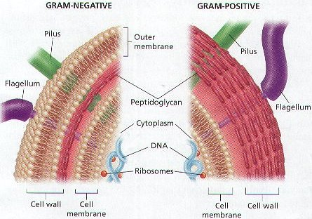

- GRAM POSITIVE BACTERIAL CELLWALL
1. Gram-positive bacteria have a thicker layer of peptidoglycan in their cell walls, made of a protein-sugar complex that takes on the purple color during gram staining.
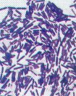
2. Gram-positive bacteria include organisms that produce beneficial substances and organisms that cause important disease.
3. They are used to make yogurt, pickles and buttermilk.
4. Another group of gram-positive bacteria are used to make antibiotics, including tetracycline and streptomycin. These bacteria are called actinomycetes.
5. Antibiotics kill other Gram-positive bacteria by preventing them from making proteins. They affect only the growth of bacteria without harming the body cells of humans.
Gram-Positive Bacteria will retain the Purple dye and appear Purple.
6. Gram-positive bacteria cause many human diseases, including scarlet fever, toxic shock syndrome, and pneumonia.
7. Many of these bacteria produce toxins, which are poisons to our bodies.
8. Toxins can be deadly; a single gram of the toxin produced by Clostridium botulinum (Botulism) could kill more than one million people.
- GRAM-NEGATIVE BACTERIA
1. Gram-negative bacteria have an extra layer of lipid on the outside of the cell wall and appear pink after gram staining.
2. The extra lipid layer stops the purple stain from entering the cell wall. They do absorb the pink stain, so they are easily distinguished with a microscope.
3. The extra lipid layer also stops many antibiotics from entering the bacteria. Treatment for these requires a different antibiotic than those used for infections caused by gram-positive bacteria.
4. These bacteria may have evolved from a photosynthetic ancestor. Some of these bacteria are still photosynthetic, but most are not.
5. These bacteria photosynthesis differ from plants, they do not release oxygen as a by-product, but produce sulfur as a by-product.
Gram-negative bacteria will appear pink from the pink dye.
6. Bacteria that produce sulfur are also called sulfur producing bacteria.

