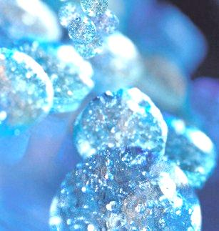

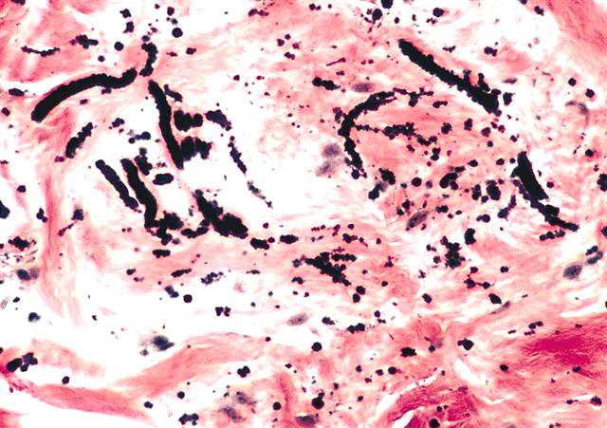
CELL BIOLOGY
ASSIGNMENT

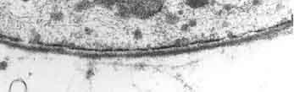

- What is the substance that lubricates joints and facilitates cell migration?

Hyaluronan (also called hyaluronic acid or hyaluronate or HA) is an anionic, nonsulfated glycosaminoglycan distributed widely throughout connective, epithelial, and neural tissues. It is unique among glycosaminoglycans in that it is nonsulfated, forms in the plasma membrane instead of the Golgi, and can be very large, with its molecular weight often reaching the millions. One of the chief components of the extracellular matrix, hyaluronan contributes significantly to cell proliferation and migration, and may also be involved in the progression of some malignant tumors.
Hyaluronan is an important component of articular cartilage, where it is present as a coat around each cell (chondrocyte). When aggrecan monomers bind to hyaluronan in the presence of link protein, large highly negatively-charged aggregates form. These aggregates imbibe water and are responsible for the resilience of cartilage (its resistance to compression). The molecular weight (size) of hyaluronan in cartilage decreases with age, but the amount increases.
Hyaluronan is also a major component of skin, where it is involved in tissue repair. When skin is exposed to excessive UVB rays, it becomes inflamed (sunburn) and the cells in the dermis stop producing as much hyaluronan, and increase the rate of its degradation. Hyaluronan degradation products then accumulate in the skin after UV exposure.
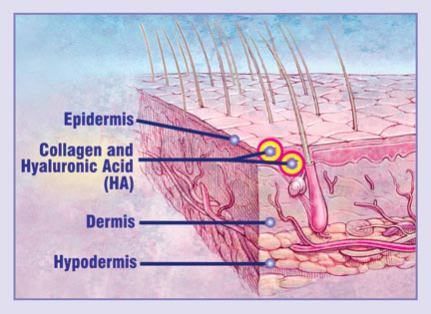

- Why elastic fibers or elastin are stretchable?
- Unique cross-links, called desmosine, made of four Lys connected through their side chains, which gives the elastin strong elastic properties.
- stretchable (rubber band-like), elastic fibrous protein
- protein of tendons, ligaments and blood vessel walls
- irregular amino acid structure; contains mostly Gly, Ala and Val with some Lys and Pro
- random coil structure, little secondary structure (not irregular structure)

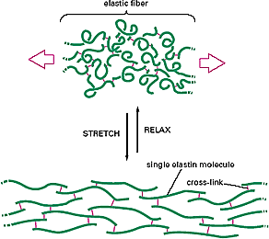

- What is the main carbohydrate component of proteoglycan?

Proteoglycans are proteins that are covalently bonded at multiple sites along the protein chain to a class of polysaccharides, known as glycosaminoglycans. Glycosaminoglycans constitute approximately 95% of the mass of proteoglycans by weight, which results in proteoglycans bearing a resemblance more to polysaccharides than to proteins. The physiological properties of proteoglycans are a function of the particular glycosaminoglycans present. Examples of common glycosaminoglycans are chondroitin 6-sulfate, keratan sulfate, heparin, dermatan sulfate, and hyaluronate. As a result of the ionic character of glycosaminoglycans, proteoglycans carry at least one negatively charged carboxylate or sulfate functional group under physiological conditions. Examples of proteoglycans include Versican, Brevican, Neurocan, and Aggrecan.
Glycosaminoglycans(GAGs) or mucopolysaccharides are long unbranched polysaccharides consisting of a repeating disaccharide unit. The repeating unit consists of a hexose (six-carbonsugar containing nitrogen).

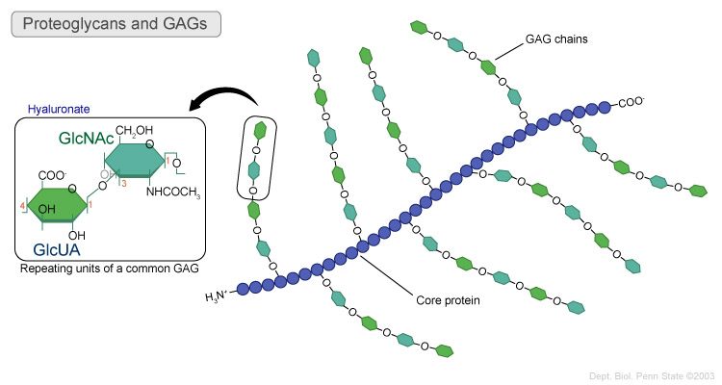

- What is basal lamina?

The basal lamina is a layer of extracellular matrix secreted by the epithelial cells, on which the epithelium sits. It is often confused with the basement membrane.

Basal Lamina

