ENDOPLASMIC RETICULUM
- Learning Objectives
- Describe endoplasmic reticulum.
- Recognize the discoverers of ER.
- Identify the two morphological forms of ER.
- Describe the functions of ER.

- Introduction
How do you travel from home to school? Do you take a road or sidewalk? Roads and sidewalks give people a path to follow as we move about our cities. A cell also has a system of tiny roads. These roads are actually tubes called the endoplasmic reticulum. Endoplasmic means "within the plasm" and reticulum means "network". The endoplasmic reticulum is a network of folded membranes that form channels. They extend from the cell membrane through the cytoplasm to the nuclear membrane.
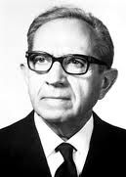
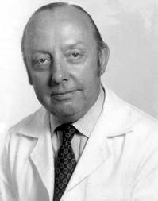
- Who discovered ER?
The ER was discovered in 1945 by Albert Claude in Belgium and Keith Porter at Rockefeller Institute. It was first noticed in the cytoplasm of chick embryo cells.
Keith Porter
Albert Claude

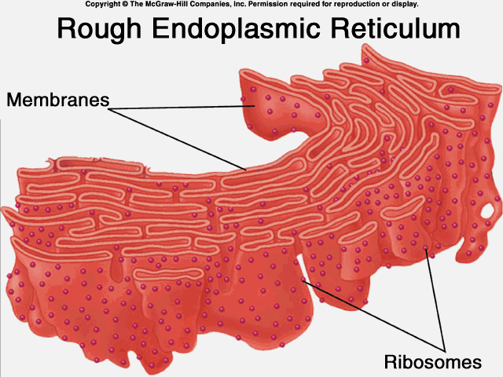
- Two Different Morphological Forms
- Rough Endoplasmic Reticulum – The surface of the rough endoplasmic reticulum (RER) is studded with protein-manufacturing ribosomes giving it a "rough" appearance.

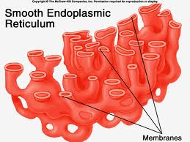
- Smooth Endoplasmic Reticulum – are involved in the synthesis of lipids, including oils, phospholipids and steroids, metabolism of carbohydrates, regulation of calcium concentration and detoxification of drugs and poisons.

- Functions

Functions
Rough Endoplasmic Reticulum (RER) | Smooth Endoplasmic Reticulum (SER)
- Involves in the synthesis of proteins that will be use outside the cell. | - Involves in the synthesis of lipids, including oils, phospholipids and steroids  - Metabolism of carbohydrates  - Regulation of calcium concentration  - Detoxification of drugs and poisons.

D

Submitted By: Jomar M. Urbano
Francis C. Geronimo
Submitted To: Ms. Aimie M. Aquino
Professor

