Chemistry of the Cell:
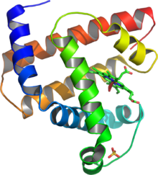
PROTEIN
- Learning Objectives:
- Discuss how protein is made.
- Describe the function and importance of protein.
- Describe structure of protein/amino acid.
- Explain what amino acid is.
- Enumerate and identify the different kinds of protein and its substances.

- Introduction:
You probably know you need to eat protein, but what is it? Many foods contain protein (say: pro-teen), but the best sources are beef, poultry, fish, eggs, dairy products, nuts, seeds, and legumes like black beans and lentils. Most people know that muscles are mainly built up by proteins. But that is just one of many tasks proteins have in our body. In fact, everything we do - think, laugh and run - emerges from the coordinated activities of a lively, intercommunicating society of protein molecules.

- What is Amino Acid?
- They are the monomers that link together to form protein.

- Sequence and Structures of Amino Acid

Sequence
Dipeptide – 2 amino acids join together
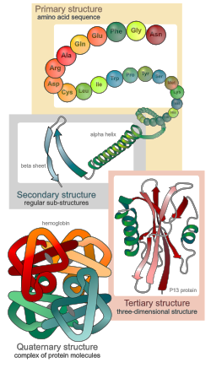
Polypeptide – consist of dipeptides
Structures
Primary structure: the amino acid sequence.
Secondary structure: regularly repeating local structures stabilized by hydrogen bonds. The most common examples are the alpha helix, beta sheet and turns.
Tertiary structure: The term "tertiary structure" is often used as synonymous with the term fold. The tertiary structure is what controls the basic function of the protein.
Quaternary structure: the structure formed by several protein molecules (polypeptide chains), usually called protein subunits in this context, which function as a single protein complex.
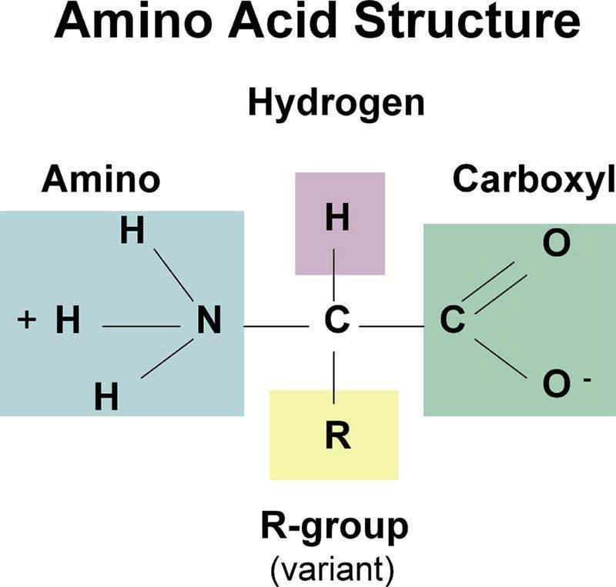
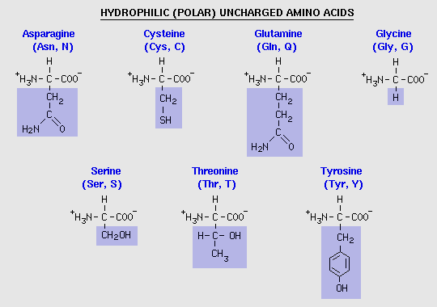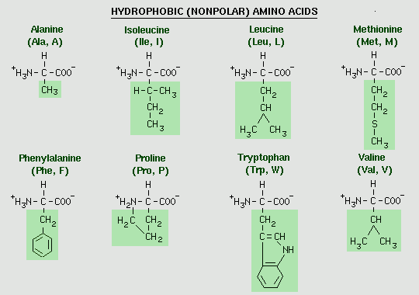
The 20 Amino Acids
Polar- Side chains which have various functional groups such as acids, amides, alcohols, and amines will impart a more polar character to the amino acid. Hydrophilic means having a strong affinity for water.
Non-polar-side chains which have pure hydrocarbon alkyl groups (alkane branches) or aromatic (benzene rings) are non-polar. Hydrophobic means lacking for water.

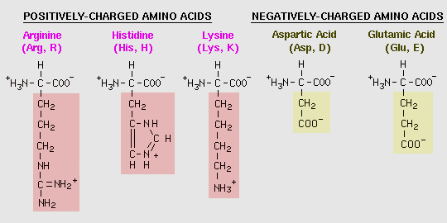

- DNA to Protein

The Central Dogma
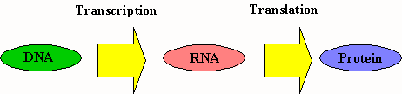

Transcription - the synthesis of RNA under the direction of DNA .
mRNA – the copy of the DNA code for the sequence of amino acids in a particular protein chain
Translation – the process of converting mRNA into a specific amino acid sequence in a protein chain.
tRNA - carries and transfer amino acid to the ribosome.
Ribosome – assembles and joins amino acids to make protein.

- What is Protein?
Gerard Johann Mulder – coined the word protein from the Greek word proteios which means “first place”
- Proteins are a sequence of amino acids.
- The most important organic compound that contain C, H, O, N, S, P, and I.
- About 20 amino acids are the building blocks of protein.
Some Functions of Proteins
Type of protein | Example | Function
Structural proteins | keratin, collagen | Hair, wool, nails, horns, hoofs, tendons, cartilage
Enzymes | amylase | Promotes the breakdown of starch to the simple sugar glucose.
Hormones | insulin, glucagon | Regulates use of blood sugar
Immunological proteins | antigen  antibodies | Substance that stimulates production of antibody  Protein that fights infection (pathogens)
Transport proteins | hemoglobin  serum albumin | Carries oxygen in blood  Carries fatty acids in blood
Contractile proteins | actin, myosin | Contracting fibers in muscle
Storage proteins | ferritin | Stores iron in spleen

- Functions of Protein

- Quality of Protein

- Complete Proteins – proteins that provide all the essential amino acids (most animal proteins)
- Incomplete Proteins – proteins that are missing one or more essential amino acids (most plant proteins except soy protein)
*Incomplete proteins can be served with a complementary protein to make it complete.
- Protein Sources

Sources | Amount in Protein in Grams
Clams (3 oz.) | 60 grams
Lean Meat | 30 grams
Almonds (1 cup) | 24 grams
Salmon (3 oz.) | 20 grams
Ham (3 oz.) | 18 grams
Pinto Beans (1 cup) | 15 grams
Yogurt (8 oz.) | 10 grams
Tofu (4 oz.) | 9 grams
2% Milk (1 cup) | 8 grams
Cheese (1 oz.) | 7 grams
1 Egg | 6 grams
White rice (1 cup) | 4 grams
Peanut Butter (1 T) | 4 grams
Whole Wheat Bread | 3 grams

References: http://en.wikipedia.org/wiki/Protein
Gerona, Zonia and Mallorca, Marion, BIOLOGY, pages 24-25

Submitted by: Group 3: Submitted to:
Jomar M. Urbano Ms. Aimie M. Aquino
Rochel B. Dayrit Professor
Re-Lyn G. Salvador
Jovelyn L. Jacinto
Lucy V. Cajigal
Jasmin L. Patricio

